**Assumptions**

1. *“All demands come from the change in the number of people due to birth, death and migration”*

We assumed that all the projects should be implemented based on the needs which might occur due to increase in the population for that particular region.

1. *“If change in another factor is stable, however is not as stable as change in another factor, then there is a need or shortage for one of the factors ”*

So, based on the data that we gathered about Social and Transportation, we tried to estimate the different values related to the number of people in that region. For example, we calculated the number of doctors per 10,000 people in any region, if the rate of change in regular number of doctors to change in regular number of people in that region is decreasing, then there is a demand for additional projects to cover the shortages.

1. *“Infrastructure should be developed based on the demand from citizens, which in case the total number of people for that particular region. All people need the same amount of resources despite their race, gender, age and social position.”*

When we estimated the values, we divided the population into 3 different groups based on their ages.

First category is Child, where the population of people aged from 0 to 16 was considered.

Second category is Adults, where the population of people aged from 16 to 63(58) was considered.

Last category is Older, where the population of people aged above 63(58).

We have tried also use different ages to estimate, however the information about each region is missing.

1. *“All the investment should go to the sector, which is going to have the highest shortage in that region among other shortages”*

We used the values from the development and infrastructure plan till 2029 to somehow estimate the future values.

**Population Estimation**

We assumed that the investment should be considered based on the change of population in a specific region. For that purpose, the possible number of population has been estimated based on the statistics about Birth Rate, Death Rate and Migration. The equation for possible calculation. We used the LinearRegression with a small of random smoothing to estimate the values for Birth Rate, Death rate, Migration for each region and from projected values we calculated population number by equation:

$N_{t+1, region} =N_{t, region} +(B_{t+1, region} + M_{t+1, region} - D_{t+1, region})$

Where, $t - year and t+1 - following year$

$N - number of population$

$B - estimated birth rate based on past$

$D - estimated death rate based on past$

$M - estimated migration based on past$

Resultant table of population after estimate based on Linear Regression with random smoothing. We assumed that the trend will be the same based on resources from 2019 to 2024. Some of the regions have been removed due to lack of resources: Abai, Zhetisu, Ulytau. The accuracy for our model was estimated by an equation:

$Accuracy = N_{estimated}/N_{actuaal} * 100 - 100$

| City | Accuracy |
| --- | --- |
| Республика Казахстан | -0.03 |
| Акмолинская | 0.73 |
| Актюбинская | 0.41 |
| Алматинская | -0.66 |
| Атырауская | 0.5 |
| Западно-Казахстанская | 0.28 |
| Жамбылская | 2.08 |
| Карагандинская | 0.67 |
| Костанайская | 0.66 |
| Кызылординская | 1.88 |
| Мангистауская | 0.03 |
| Павлодарская | 0.97 |
| Северо-Казахстанская | 1.29 |
| Туркестанская* | 2.18 |
| Восточно-Казахстанская | 0.15 |
| г. Астана | -0.17 |
| г. Алматы | -0.29 |
| г. Шымкент | 0.12 |

**Energy**

To identify the condition of energy, we have tried to calculate the total energy consumed by each region, the total number of people, the amount of stations and the capacity of each station and the price for each type of energy. The equation is following:

$E_{t+1} = E_{t}/N_{t} * N_{t+1}$

$Needed amount of stations = E_{t+1}/C$

Where E - energy consumed by that particular year

N - population for that year

t - year and t + 1 - following year

C - capacity of each station

$Money needed from a person = (E_{t+1}/N_{t+1} *P)$

Where $E_{t+1} - energy consumed for following year$

$N_{t+1} - amount of people for following year$

$P - price per KWath energy$

By having those values, we can linearly project and estimate the future price for a unit of energy. By adding the inflation rate + interest of payback period of 5 years (until 2029). Each time for regular price of energy will be added another price to pay back any investments.

The same procedure has been done for all other source types, like water and electricity. So each investment can be returned by adding additional cost to the price per unit of energy source. However, due not availability of all resources and some materials not have stable price, the train of predictive model wasn’t possible.

**Transport**

For the sector of Transport, we have identified some major factors, like the number of available transportation amounts, the length of all roads, the number of population and the price for the transportation, roads of international and local road length.

$T_{t+1} = T_{t}/N_{t} * N_{t+1}$

Where T - number of available transports

N - number of people in that particular region

t - year and t + 1 - for following year

By the equation above, the possible amount of public transport is calculated. A similar equation was used to calculate the amount of potential number of passengers of public transport.

$P_{t+1} = P_{t}/N_{t} * N_{t+1}$

Where R - number of passengers

N - number of people in that particular region

After the application of each equations, the total investment is calculated for following changes:

$P_{t+1} =( P_{t} N_{t} + Investment) /N_{t+1}$

Where P - price for public transport

Investment - planned investment to cover new demands

N - number of people in that particular region

First, the price for transportation is estimated without application of new investment by Linear Regression with random smoothing. After that new price estimation, we add another cost to payback all the investments done for that region. Again, due to lack of available information, we couldn’t calculate the possible investment needed in the region and the possible price, but still calculated the possible amount of passengers as well as needed bus amount for each particular region.

**Social**

Social factors include the amount of medical and education buildings. To estimate the need for future number of building, we used the following equations:

${Coefficient}_{t} = M_{t}/N_{t}$

Where M - number of medical buildings in a particular region;

N - amount of people in a specific region;

LinearRegression was used to predict future values of ration based on the estimated number of doctors and people in the region. The coefficient decrease means there is a shortage, while being stable means there will be enough doctors.

By estimating the amount of needed hospitals, there is a probable need in the amount of hospitals. The same methods have been used for estimating the number of education buildings.

$Coefficientt_{t} = E_{t}/N_{t}$

Where E - number of educational buildings in a particular region;

N - amount of people in a specific region;

By above calculations, we have tried to estimate the possible needs among each region to possibly assess the level of priority and by finding the average cost of one school per one additional student, we could calculate the amount of investment per a new school. However, due to a shortage of data, the calculations were impossible. The same price should have been used for hospitals, etc.

All other drivers like the number of schools, universities, kindergartens have been estimated by the LinearRegression algorithm based on the change in the population. We have also tried to estimate based on the number of teachers, medical workers to somehow estimate the shortage of employees in the Social sector.

**Projects**

Currently Kazakhstan is preparing the projects to improve the quality of each sector in Kazakhstan. However, not all the

1) энергетическая инфраструктура – 46 проектов;

2) транспортная инфраструктура – 59 проектов;

3) инфраструктура водоснабжения и водоотведения – 89 проектов;

4) цифровая инфраструктура – 10 проектов.

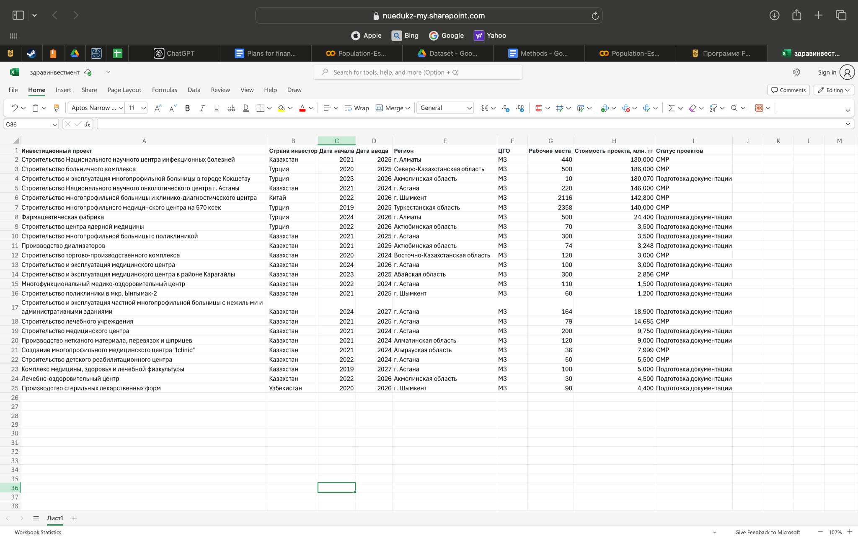

**еInvestment**

After identifying needs and demands, we come to realize that most of the schools, colleges and kindergartens need repair or new ones. To solve the problem, we need another type of investment. For that reason, “BI Group” can be considered as the best option. Currently, ‘BI Group’ is working in a project to build schools in cities Astana and Atyrau. In 2024, the company established 6 schools around Astana and 2 schools in Atyrau, where in total 32,000 students are studying and 1,600 teachers are working. Based on those values, approximately each school of ‘BI Group’ can provide seats for 4,000 students and a working place for 200 teachers. Some other reasons to consider the project is following:

* **Оснащенность**
  + Школы BINOM построены по высочайшим стандартам. Количество оборудования для учебы больше в 5 раз, чем в обычной школе.
* **Качество**
  + Отбор учителей в BINOM SCHOOL проводится на крупнейшей интернет-платформе Jumys Smart Nation, это приложение позволяет охватить более 270 000 преподавателей со всех регионов страны и выбрать из них сильнейших в своем предмете.
* **Доступность**
  + BINOM – школы со смешанным языком обучения. Обучение здесь бесплатное: набор детей осуществляется на основе Типовых правил приема на обучение в организации образования РК.

Why ‘BI Group’ might be interested in continuing the project in other regions:

1. ‘BI Group’ will get financial support from government for each child that is studying in their schools;
2. By planning the infrastructure, ‘BI Group’ can plan their own projects based on the project. For example, for several accommodations in the region, ‘BI Group’ can build a single school, so the entire complex is led by the company itself.
3. If the company get the permission to build other types of buildings like hospitals, clinics, then the impact of ‘BI Group’ as a company can be improved and all other projects can be led by ‘BI Group’.

**Conclusions**

Based on the change in the population, we have tried to estimate the need in the next 5 years. We haven’t been able to estimate the most priority, but we have attempted to estimate the need to make a choice. For example, in 2025 there will be a need for additional universities in Karaganda due to an increase in the population of that city. By those changes, we can estimate the needed amount of infrastructure in different parts of Kazakhstan. If there were additional days, more precise and efficient results would be obtained and reported.

**Limitations**

1. **Dataset Limitation:** some data is missing, irrelevant, incorrect. The more structured dataset creation takes a huge amount of time;
2. **Too optimistic**: the calculations were calculated based on the theory that the increase in each variable might be constant in the future. So our estimation is made for best case situations, so for some worst case scenarios, the calculations will be wrong.
3. **Overgeneralized**: the assumption that there is no difference in the need regarding the age, race, ethnicity and gender is not correct, however due to limited amount of time and resources, that assumption was the key to make analysis and calculations;
4. **Simple**: simple mathematical equations and Machine learning algorithms have been used due to limitation in computational resource, to have more complex models and calculations, more computational resources are needed;

Для Исмы и Айзады:

Жамбылская область занимает одно из ведущих мест в Казахстане по развитию сельского хозяйства, демонстрируя высокие показатели в животноводстве и растениеводстве. Однако, несмотря на успехи в аграрном секторе, социальная инфраструктура региона, в частности школы, больницы и университеты, остаются в неудовлетворительном состоянии. В области остро ощутима разница между городами и сельской местность. Школы в сельской местности в основном страдают от износа и недостатка учителей. Это создаёт серьёзные проблемы для населения, особенно в сельских районах, где доступ к качественному образованию и медицинским услугам ограничен. Для решения этой проблемы можно перераспределить средства, инвестируемые в сельское хозяйство, в сторону строительства и модернизации образовательных учреждений, особенно в рамках программы "Комфортная школа". Это обеспечит качественное обучение для будущих специалистов и повысит общий уровень жизни в регионе.

Для решения этой проблемы можно перераспределить средства, инвестируемые в сельское хозяйство, в сторону строительства и модернизации образовательных учреждений, особенно в рамках программы "Комфортная школа". Вложение в проект "Комфортная школа" обеспечит создание комфортных условий для обучения, что, в свою очередь, повысит качество образования, улучшит социальную инфраструктуру и поддержит устойчивое развитие региона.

Вложение в проект **"Комфортная школа"** является стратегически важным для региона. Так как **"Комфортная школа"** предоставляет такие возможности:

1. **Современные условия обучения**: Оснащение классов современным оборудованием и комфортной мебелью, хорошей вентиляцией и освещением создают условия, способствующие успешному обучению.
2. **Инклюзивность и доступность**: В рамках программы уделяется внимание созданию доступной среды для детей с особыми образовательными потребностями, что способствует интеграции всех учеников.
3. **Энергосбережение и экология**: Применение экологически чистых технологий, таких как солнечные панели и системы вентиляции с рекуперацией тепла, снижает расходы на энергоснабжение и способствует устойчивости к изменениям климата.
4. **Качество образования**: Внедрение цифровых технологий и современных образовательных методик повысит качество обучения и вовлеченность учащихся.
5. **Безопасность и здоровье**: Школы оснащены спортивными и медицинскими кабинетами, а также предлагают программы по физическому воспитанию и организации досуга.
6. **Технические новшества**: Внедрение новых технологий и специализированных классов для изучения наук, искусства и языков улучшит подготовку учеников.